Tillamook County Short-Term Rental program is accepting existing emergency escape & rescue openings based on the following table.
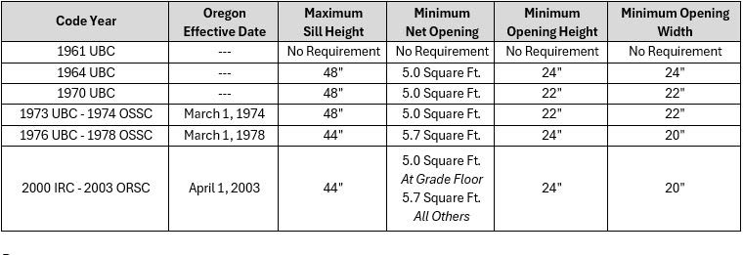
If the existing window does not meet the maximum sill height requirement, the step in the diagram below is accepted as a temporary measure for the current inspection.

The window will need to be lowered and the step removed prior to the 3-year reinspection.

