Dear Representative Bonamici,

We are the Tillamook County Housing Commission. Our mission is to collaboratively advocate for attainable and equitable solutions that impact Tillamook County’s greatest housing needs.
A phrase we frequently hear is: “we have city sized problems with rural sized resources”. This is a frustratingly true statement, made even more so as we must continually turn down federal support to address our greatest needs due to unreasonably high requirements that rural communities do not have the ability to meet.

Recently, Tillamook County was included in a successful grant application to the Environmental Protection Agency’s Climate Pollution Reduction Grant Program (CPRG). The grant is to incentivize the construction of space efficient housing (of < 800 sq ft) at $20,000 per unit. This is an excellent match for Tillamook County where one of our most important housing strategies is to support the development of ADU’s.

In Tillamook County, land and infrastructure availability are two of the greatest challenges to housing production and ADU's are excellent infill housing that allows us to make the most use of the existing infrastructure and developed land. ADU’s are also good for the social fabric of Tillamook County, where multi-generational living is commonplace. ADU’s help to keep families close, build social capital, and address a critical need in our housing shortage.

Unfortunately, it seems that the CPRG funding from the EPA will not be able to be used to support ADU production for a reason that has the same taste as ‘city sized problems with rural sized resources’: Davis-Bacon requirements. The average cost to add a 800 sq ft ADU to a single family home is roughly $200,000. If a homeowner wishing to add an ADU were to accept a $20k incentive for this project, the associated requirements would add roughly $60k to the cost of the project.

Even more frustrating is that the CPRG funds cannot even be used to pay the system development charges without triggering Davis-Bacon requirements, making it more difficult to both incentivize housing and develop critical housing infrastructure.

HUD has a small project exemption for Davis-Bacon of $750,000, for good reason. It is impossible for a housing development to absorb prevailing wage costs when the project is below this size. We urge you, Senator, to help find a way to let rural communities better partake in federal housing resources! Help us right size the available resources so that they work to address both rural and urban housing needs.

We appreciate your consideration,
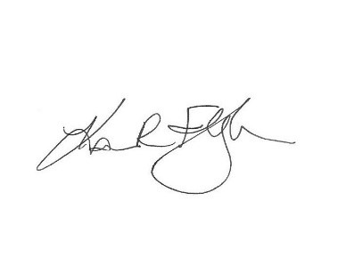
Kari Fleisher

Chair of the Tillamook County Housing Commission
Members:

